Lab: Lab 2 — Floating-Point Number Conversions
Name: Solomon Ewusi | Student ID: N01659373
Date: September 26, 2026

Please refer to the lab manual posted on the blackboard and fill in the blanks in the following table as your lab report.

Notice: All labs are individual work and submission. All academic misconduct behaviors will be penalized to the maximum extent possible according to college policy. Thanks for your attention. (Reference Link: About Academic Misconduct)

Fill in all the lab report submission requirements in the following table. Please add more rows if necessary.

Requirements | Your submissions (Answers/Source Code/Screenshots/File Submissions, etc.)  Please notice: If it is required to submit a separate file, please attach it separately on the blackboard.
Part 2 – Question  Screenshots of the Novabench
  Overall Score | 5269
  CPU Model | AMD Ryzen 7 9700F
  CPU Score | 2648
  GPU Score | 1721
  RAM Score | 423
  Disk Score | 477
  Disk Write Speed | 4606 MB/s (Sequential), 219 MB/s (Random)
  Disk Read Speed | 5893 MB/s (Sequential), 52 MB/s (Random)
  RAM Read Speed | 29147 MB/s (Single-thread), 24015 MB/s (Multi-thread)
  GPU Model | NVIDIA GeForce RTX 5070 (12GB)
  NOVABENCH SCREENSHOTS
  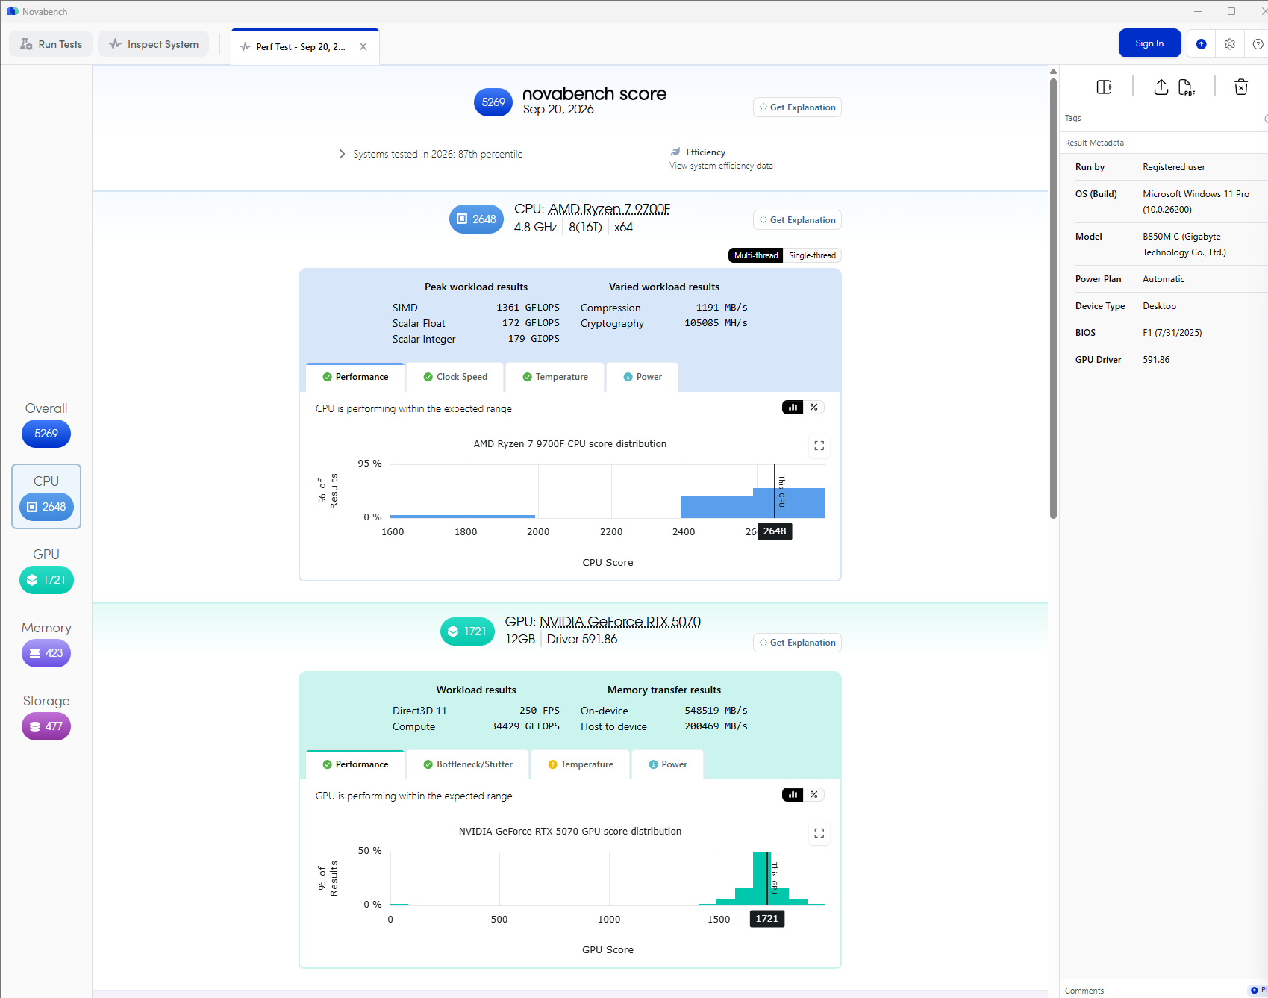
  Novabench: Overall, CPU, and GPU results
  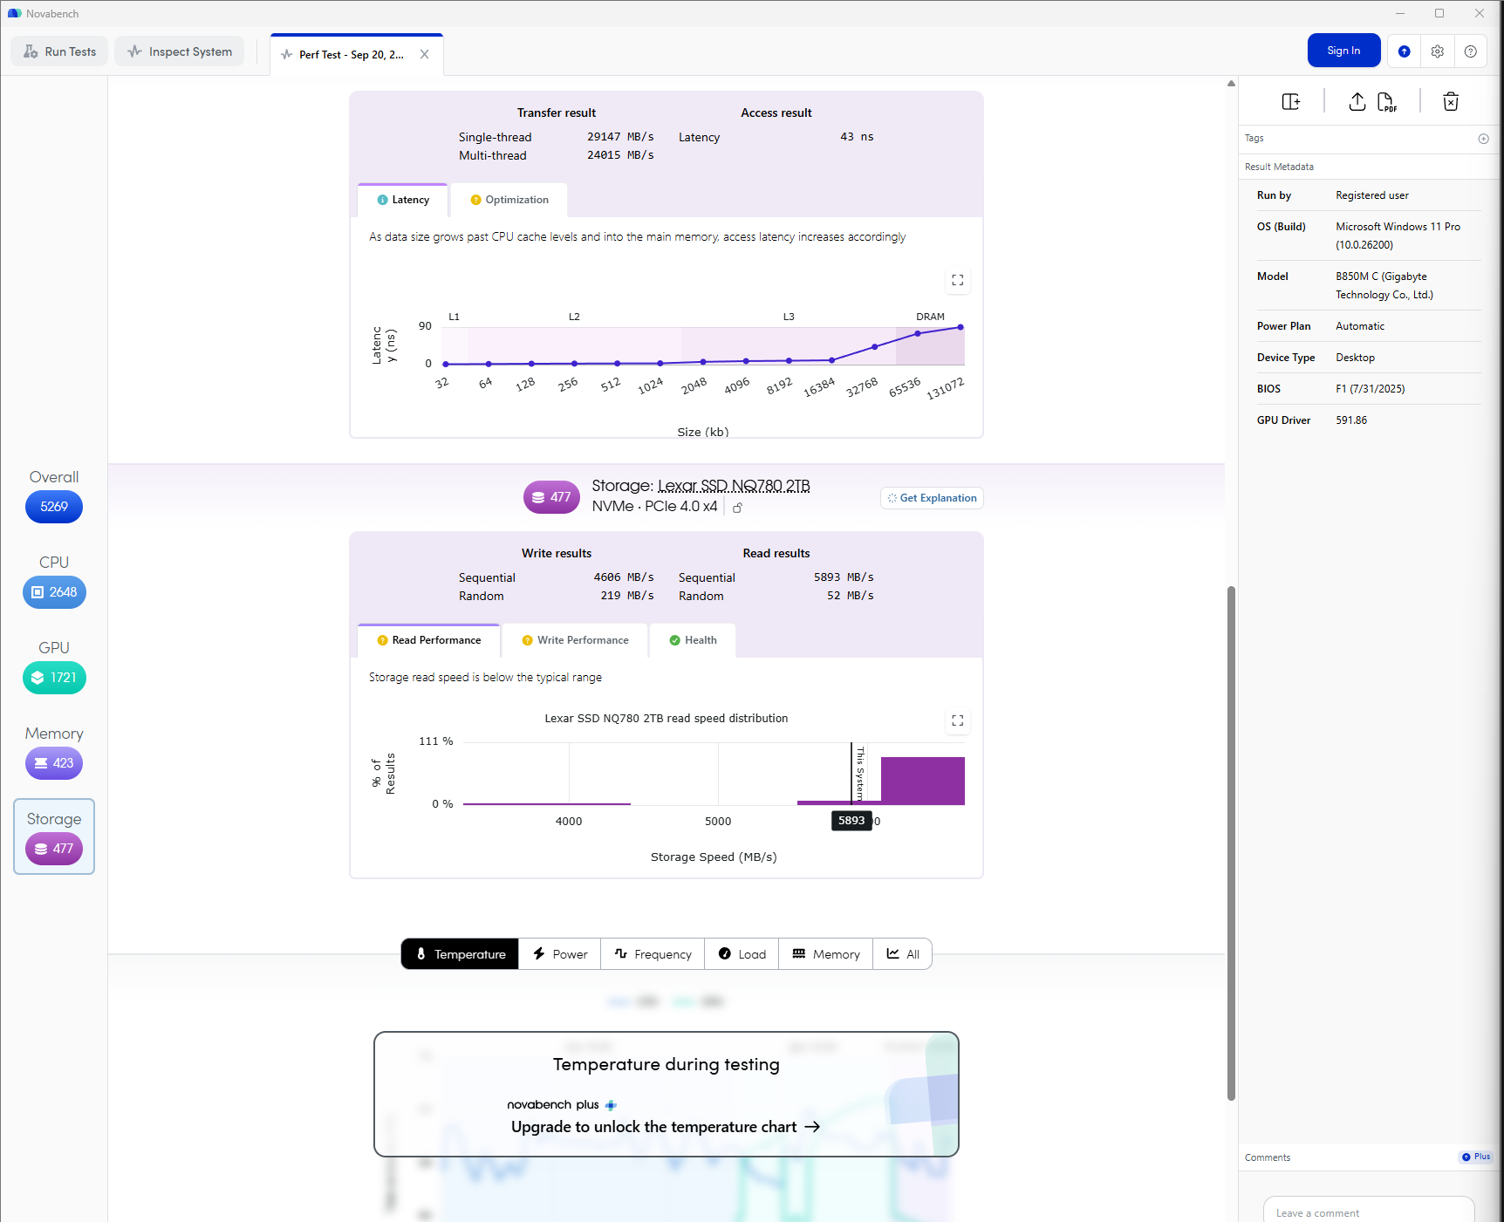
  Novabench: Memory and Storage results
Your source code (in C programming language) | Please submit the source code as a separate file.  lab2.c is attached separately on Blackboard
Screenshots of the code’s running results (at least 4 cases: 2 cases for whole numbers in option 1; and 2 cases for floating-point numbers in option 2.) | ONLINE COMPILER (ONLINEGDB)  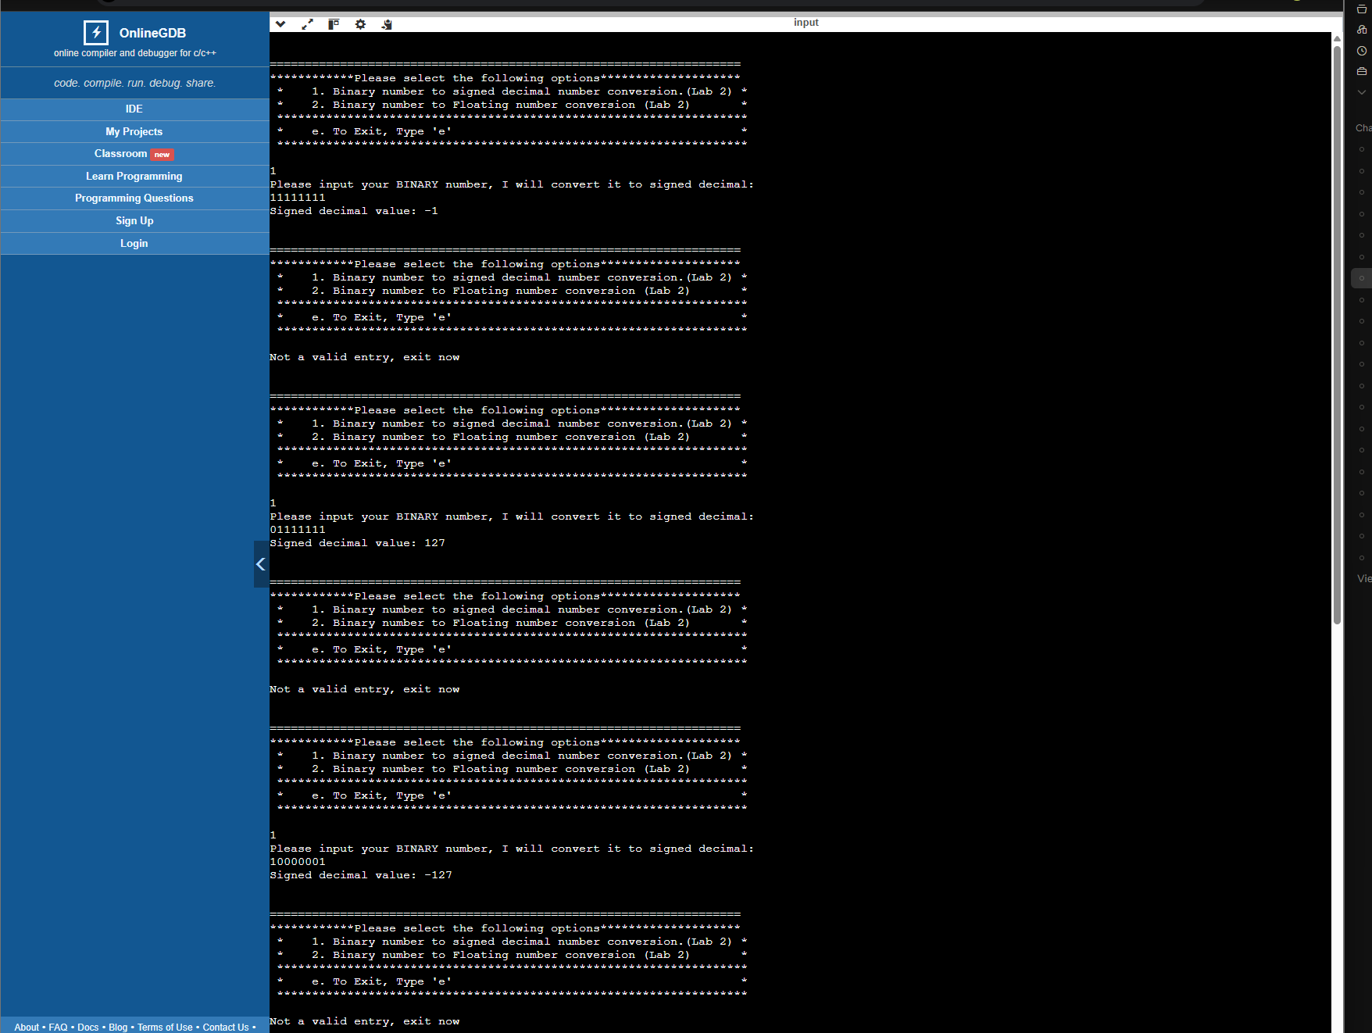  Option 1 test cases (OnlineGDB)  ONLINE COMPILER (ONLINEGDB)  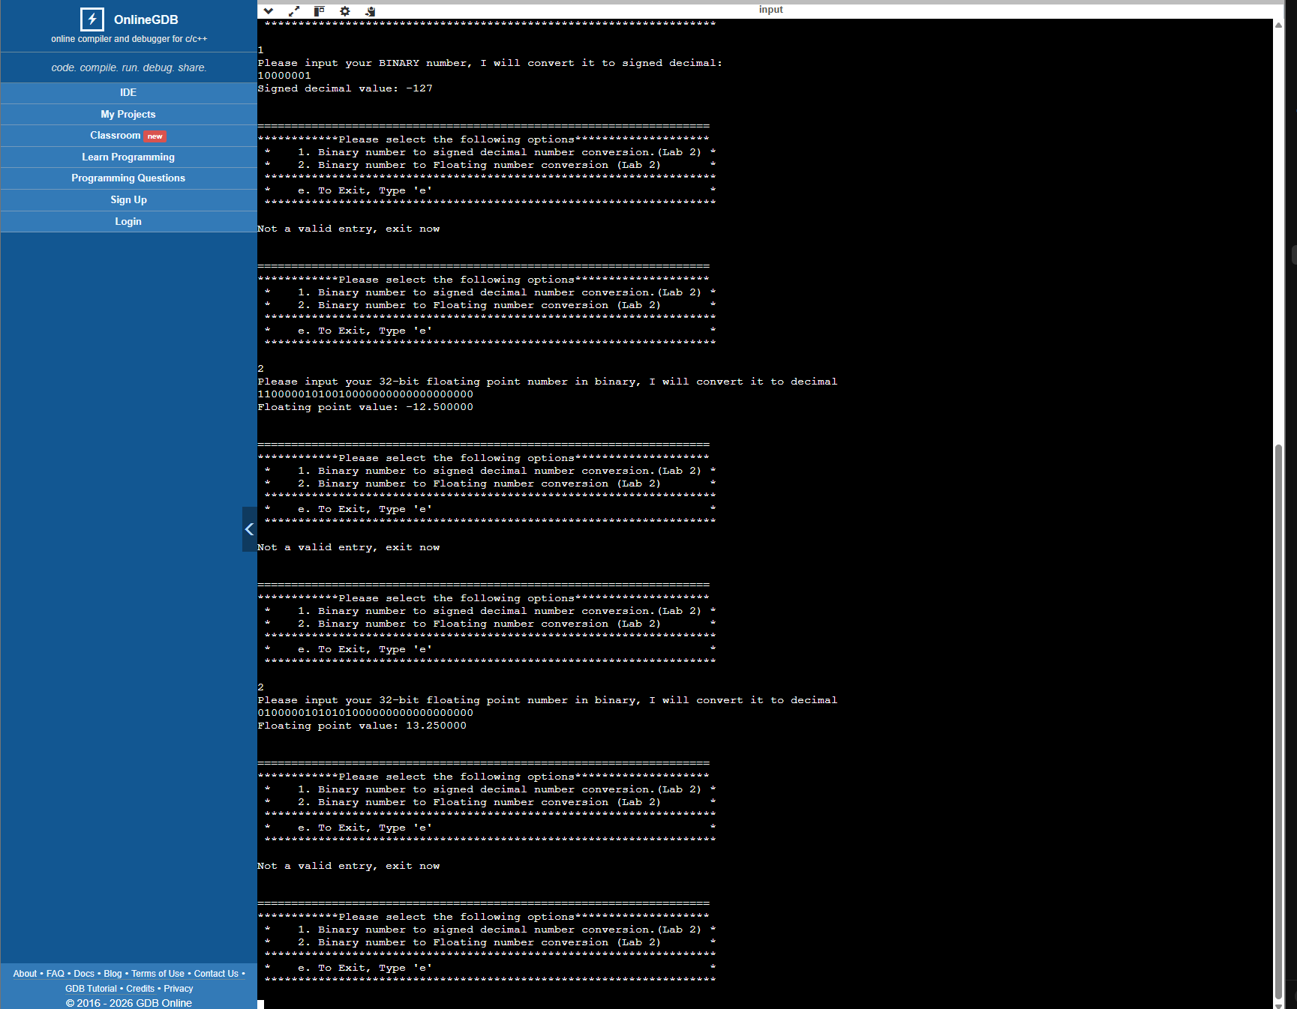  Option 2 test cases (OnlineGDB)  LOCAL PC (MINGW)  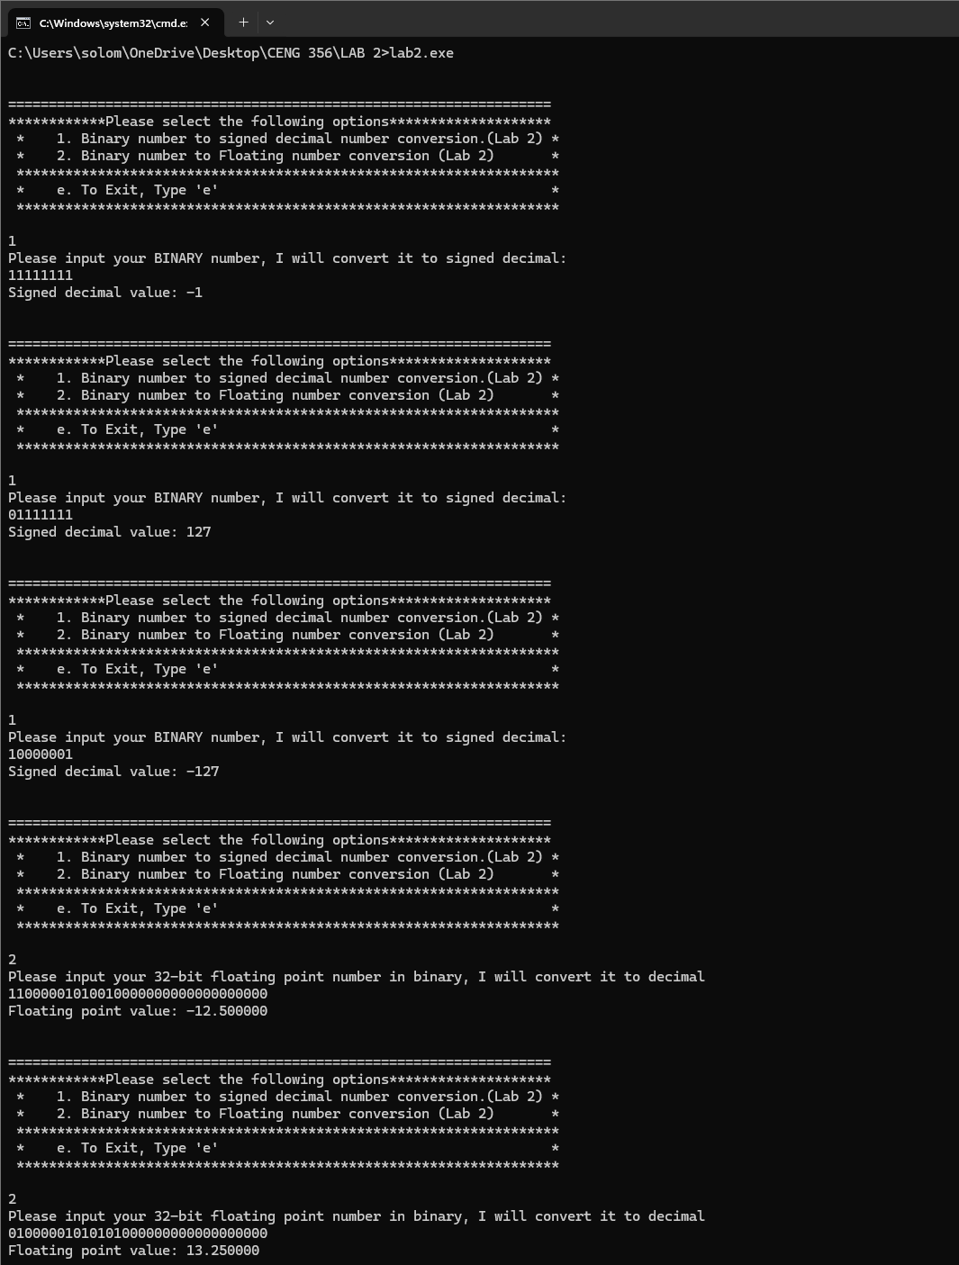  Options 1 and 2 test cases (Local PC, MinGW)  LOCAL PC (MINGW)  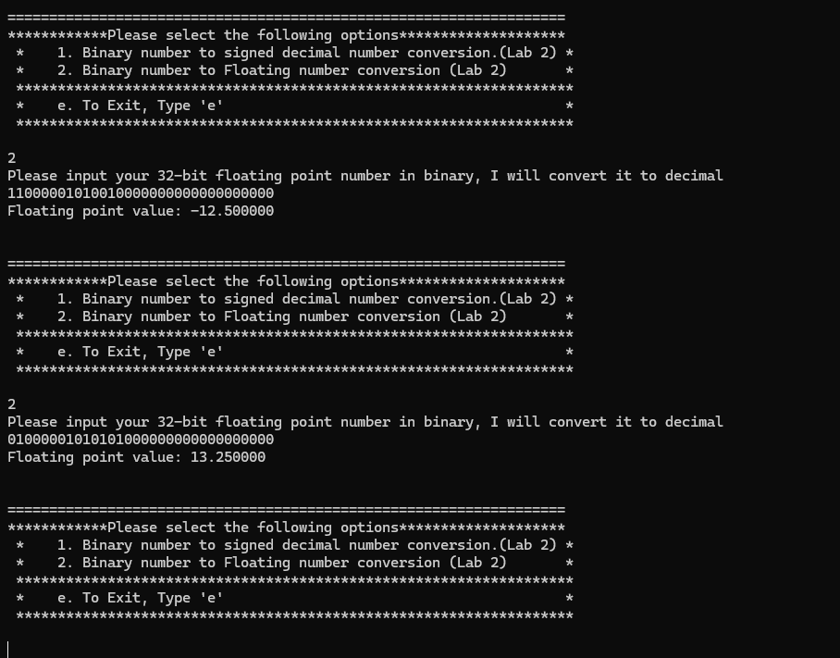  Option 2 test cases, close-up (Local PC, MinGW)

